1. **cricketapp**

**AIM:**  Create a React Application named “cricketapp” with the following components:

1. Listofplayers
2. Indian players

**Program:**

**ListofPlayers.js**

import React from 'react';

const ListofPlayers = () => {

const players = [

{ name: "Virat Kohli", score: 85 },

{ name: "Rohit Sharma", score: 65 },

{ name: "Shubman Gill", score: 72 },

{ name: "Suryakumar Yadav", score: 45 },

{ name: "KL Rahul", score: 90 },

{ name: "Hardik Pandya", score: 55 },

{ name: "Ravindra Jadeja", score: 88 },

{ name: "Axar Patel", score: 60 },

{ name: "R Ashwin", score: 68 },

{ name: "Mohammed Shami", score: 40 },

{ name: "Jasprit Bumrah", score: 77 },

];

// Filter players with score below 70

const lowScoringPlayers = players.filter(player => player.score < 70);

return (

<div>

<h2>All Players</h2>

<ul>

{players.map((player, index) => (

<li key={index}>{player.name} - Score: {player.score}</li>

))}

</ul>

<h2>Players with Score below 70</h2>

<ul>

{lowScoringPlayers.map((player, index) => (

<li key={index}>{player.name} - Score: {player.score}</li>

))}

</ul>

</div>

);

};

export default ListofPlayers;

**IndianPlayers.js:**

import React from 'react';

const IndianPlayers = () => {

const players = ["Rohit", "Gill", "Kohli", "SKY", "Rahul", "Hardik"];

// Destructure Odd and Even Players

const oddPlayers = players.filter((_, index) => index % 2 === 0);

const evenPlayers = players.filter((_, index) => index % 2 !== 0);

// Merge two arrays

const T20players = ["Kohli", "Rohit", "Hardik"];

const RanjiTrophyPlayers = ["Pujara", "Rahane", "Ashwin"];

const mergedPlayers = [...T20players, ...RanjiTrophyPlayers];

return (

<div>

<h2>Odd Team Players</h2>

<ul>

{oddPlayers.map((player, index) => (

<li key={index}>{player}</li>

))}

</ul>

<h2>Even Team Players</h2>

<ul>

{evenPlayers.map((player, index) => (

<li key={index}>{player}</li>

))}

</ul>

<h2>Merged Team (T20 + Ranji)</h2>

<ul>

{mergedPlayers.map((player, index) => (

<li key={index}>{player}</li>

))}

</ul>

</div>

);

};

export default IndianPlayers;

**App.js:**

import React from "react";

import ListofPlayers from "./Components/ListofPlayers";

import IndianPlayers from "./Components/IndianPlayers";

function App() {

const flag = true; // Change to false to display IndianPlayers

return (

<div className="App">

<h1>Welcome to Cricket App</h1>

{flag ? <ListofPlayers /> : <IndianPlayers />}

</div>

);

}

export default App;

**Output:**

1. **When flag = true**

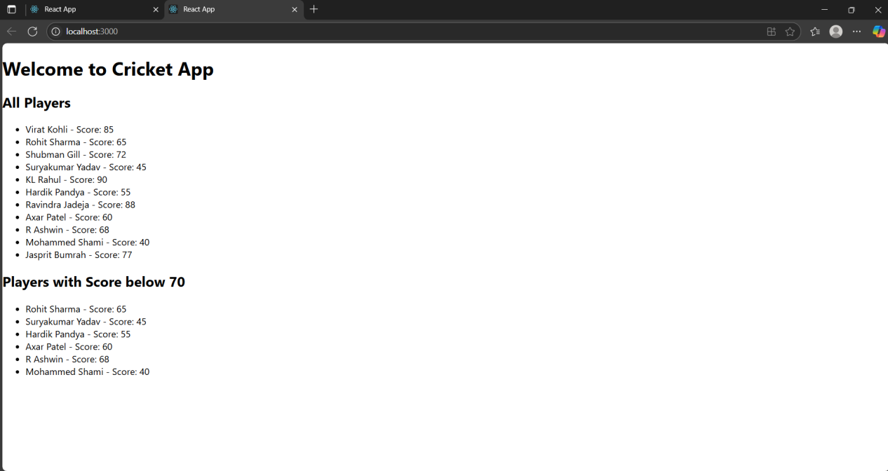

1. **when flag = false**

